**A method is a block of code which only runs when it is called.**

**You can pass data, known as parameters, into a method.**

**Methods are used to perform certain actions, and they are also known as functions.**

**Why use methods? To reuse code: define the code once, and use it many times.**

Code

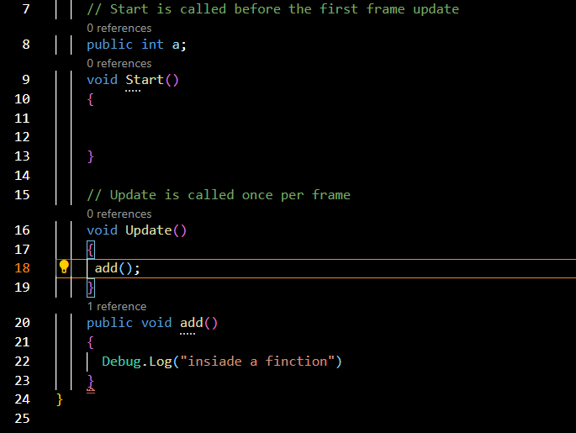

Output

